Cointegration and ECM: USDJPY and EURGBP
Method 27 / Engle-Granger on log closes / one-lag ECM / Alpari D1 full available history

Study setup
Logical pair: PX=USDJPY , PY=EURGBP
Broker symbols: USDJPY_i , EURGBP_i
Snapshot: 2026-11-03_majors_alpari_D1
Timeframe: D1
Matched window: 1999-01-06 to 2026-11-02 (UTC bar dates)
Matched level count n: 7181
Dropped unfinished last bar dated 2026-11-03 UTC after a tick-volume check against the prior complete day.
ECM lags of deltas: 1
Complete matched rows (Excel): USDJPY-EURGBP_Coint_D1.xlsx
Complete matched rows (HTML table): USDJPY-EURGBP_Coint_D1_data.html

Method carried forward
Engle-Granger cointegration works on log price levels, not returns. For each unordered pair, PX is the left leg and PY the right leg. Step one: OLS ln(PY) = alpha + beta * ln(PX) + e. Step two: statsmodels Engle-Granger coint test on (ln(PY), ln(PX)). Error-correction: delta ln(PY)_t = c + kappa * e_{t-1} + lagged delta ln(PY) and delta ln(PX) (one lag each) + u_t. Headline is the Engle-Granger p-value (lower = stronger evidence of a stationary spread) with kappa and beta reported alongside. Same-sample Pearson r of log returns is a side check only. beta is not an automatic lot-size hedge. This is not a trading signal.

Results (headline)
alpha: 0.124492
beta: -0.078788
Engle-Granger t: -1.456437
Engle-Granger p: 0.777515
5% critical value: -3.336981
ECM kappa: -0.000745
kappa t-stat: -1.6496
ECM R^2: 0.000554
spread std: 0.127389
Pearson r (returns): -0.127992

Conclusion
Engle-Granger for PY=EURGBP on PX=USDJPY: beta=-0.0788, alpha=0.1245, coint_t=-1.4564, p=0.7775 (5% crit=-3.3370). ECM kappa=-0.0007 (t=-1.65). Pearson r of returns = -0.1280. beta is not a lot-size hedge. Not a trading signal.

Charts
Daily closes

Engle-Granger residual spread
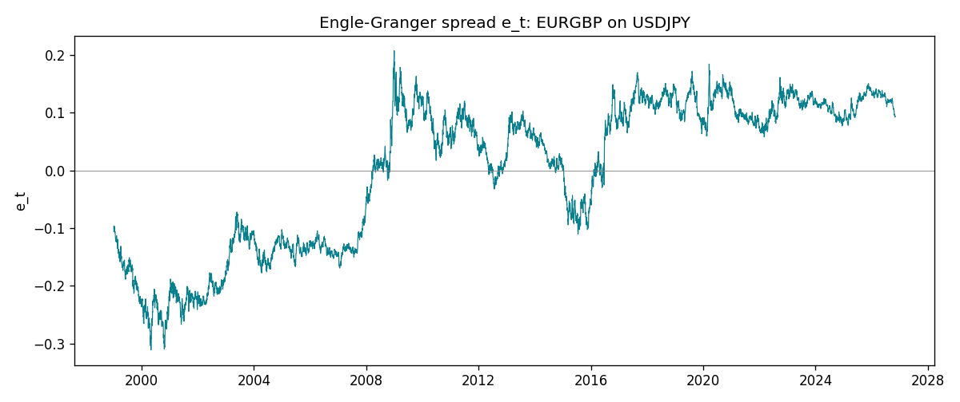
Daily log returns
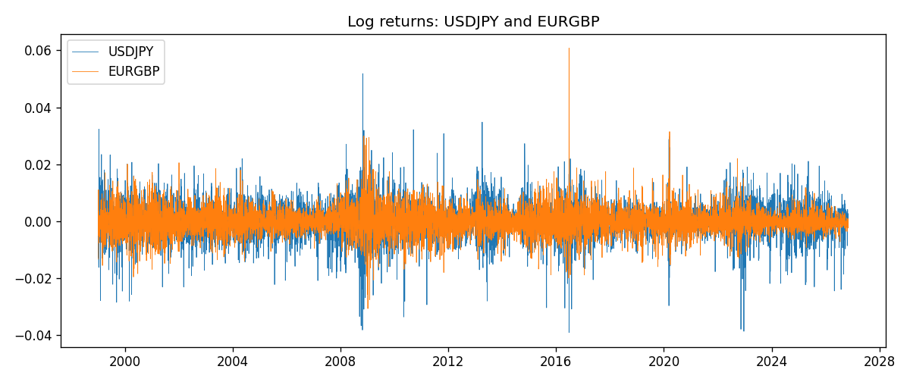

Data report
Matched rows are in the sibling Excel workbook named USDJPY-EURGBP_Coint_D1.xlsx. Embedding all rows as a Word table is impractical; this file holds column summaries and the first and last 15 matched rows.
Column summaries
column | count | mean | std | min | 25% | 50% | 75% | max
USDJPY_open | 7181 | 113.80773 | 19.228846 | 75.693 | 104.38 | 110.98 | 120.71 | 163.824
EURGBP_open | 7181 | 0.78701429 | 0.09663819 | 0.5734 | 0.6877 | 0.83392 | 0.86523 | 0.9769
USDJPY_high | 7181 | 114.30513 | 19.290536 | 76.001 | 104.865 | 111.439 | 121.27 | 163.978
EURGBP_high | 7181 | 0.79009197 | 0.09701345 | 0.5789 | 0.6897 | 0.83701 | 0.8681 | 0.9799
USDJPY_low | 7181 | 113.28458 | 19.156841 | 75.402 | 103.87 | 110.53 | 120.172 | 163.628
EURGBP_low | 7181 | 0.78431381 | 0.09645598 | 0.5682 | 0.6857 | 0.83166 | 0.86287 | 0.9661
USDJPY_close | 7181 | 113.82069 | 19.244339 | 75.811 | 104.38 | 111.015 | 120.695 | 163.851
EURGBP_close | 7181 | 0.78705735 | 0.09663932 | 0.5735 | 0.6878 | 0.83401 | 0.86539 | 0.977
USDJPY_tick_volume | 7181 | 106398.86 | 179473.16 | 149 | 9958 | 53207 | 92916 | 1803508
EURGBP_tick_volume | 7181 | 87156.048 | 145513.65 | 154 | 6593 | 44384 | 81451 | 1424684
USDJPY_spread | 7181 | 20.250104 | 17.60648 | 0 | 6 | 11 | 30 | 50
EURGBP_spread | 7181 | 21.316669 | 19.115948 | 0 | 4 | 13 | 40 | 50
USDJPY_real_volume | 7181 | 3.4800425e+10 | 1.6097887e+11 | 0 | 0 | 0 | 0 | 3.8834203e+12
EURGBP_real_volume | 7181 | 2.788005e+10 | 1.3523257e+11 | 0 | 0 | 0 | 0 | 3.5726265e+12
USDJPY_log_price | 7181 | 4.7205252 | 0.16797712 | 4.3282434 | 4.6480381 | 4.7096653 | 4.7932667 | 5.0989575
EURGBP_log_price | 7181 | -0.24742681 | 0.12807457 | -0.55599734 | -0.37425718 | -0.18150989 | -0.14457501 | -0.02326863
USDJPY_log_return | 7181 | 4.847e-05 | 0.00620794 | -0.03908203 | -0.00320533 | 0.00011473 | 0.00340924 | 0.05184024
EURGBP_log_return | 7181 | 2.133e-05 | 0.00487349 | -0.03067367 | -0.00262366 | -0.00010035 | 0.00255918 | 0.06075387
spread_e | 7181 | 0 | 0.12738894 | -0.31080432 | -0.12697075 | 0.05876991 | 0.10989097 | 0.20692594
ecm_fitted | 7180 | 2.318e-05 | 0.00011466 | -0.00046684 | -6.361e-05 | 8.7e-07 | 0.00011044 | 0.00068234
First 15 matched rows (selected columns)
time | USDJPY_log_price | EURGBP_log_price | spread_e | USDJPY_log_return | EURGBP_log_return
1999-01-06 | 4.7253503 | -0.35396434 | -0.10615737 | 0.0075660159 | -0.013303338
1999-01-07 | 4.7124988 | -0.34291293 | -0.096118511 | -0.012851583 | 0.011051402
1999-01-08 | 4.7077268 | -0.3478568 | -0.10143835 | -0.0047719894 | -0.004943862
1999-01-11 | 4.6915314 | -0.34913203 | -0.10398959 | -0.016195423 | -0.0012752393
1999-01-12 | 4.7238417 | -0.345735 | -0.098046897 | 0.032310364 | 0.0033970309
1999-01-13 | 4.731979 | -0.34531119 | -0.096981959 | 0.0081373171 | 0.00042381861
1999-01-14 | 4.731979 | -0.34729054 | -0.098961317 | 0 | -0.0019793588
1999-01-15 | 4.7375134 | -0.35496213 | -0.10619686 | 0.0055343401 | -0.0076715819
1999-01-18 | 4.737601 | -0.35424932 | -0.10547715 | 8.7600193e-05 | 0.00071280921
1999-01-19 | 4.731979 | -0.35567544 | -0.10734622 | -0.0056219403 | -0.0014261269
1999-01-20 | 4.726591 | -0.35367943 | -0.10577472 | -0.0053879917 | 0.0019960086
1999-01-21 | 4.7350574 | -0.35439184 | -0.10582007 | 0.0084664056 | -0.00071240297
1999-01-22 | 4.7410987 | -0.35610368 | -0.10705593 | 0.0060412564 | -0.0017118406
1999-01-25 | 4.7337393 | -0.36154392 | -0.11307601 | -0.0073594164 | -0.0054402425
1999-01-26 | 4.7349696 | -0.3621183 | -0.11355346 | 0.0012303367 | -0.00057438255
Last 15 matched rows (selected columns)
time | USDJPY_log_price | EURGBP_log_price | spread_e | USDJPY_log_return | EURGBP_log_return
2026-10-13 | 5.0645236 | -0.16891582 | 0.10561381 | -0.0018932826 | 0.00020130374
2026-10-14 | 5.0645994 | -0.16779163 | 0.10674397 | 7.5800166e-05 | 0.0011241873
2026-10-15 | 5.0627469 | -0.1686672 | 0.10572244 | -0.0018524319 | -0.00087557391
2026-10-16 | 5.0623672 | -0.17070529 | 0.10365444 | -0.00037976126 | -0.0020380844
2026-10-19 | 5.0658618 | -0.1712748 | 0.10336027 | 0.0034946841 | -0.00056950988
2026-10-20 | 5.0636072 | -0.17486542 | 0.099592001 | -0.0022546642 | -0.0035906254
2026-10-21 | 5.0632783 | -0.17627189 | 0.098159623 | -0.00032883504 | -0.00140647
2026-10-22 | 5.0546841 | -0.17814629 | 0.095608109 | -0.0085942669 | -0.0018743924
2026-10-23 | 5.0550349 | -0.17732208 | 0.096459958 | 0.00035080446 | 0.00082421033
2026-10-26 | 5.0591588 | -0.17719074 | 0.096916202 | 0.0041238746 | 0.00013133309
2026-10-27 | 5.0619239 | -0.17918648 | 0.095138328 | 0.0027651658 | -0.0019957343
2026-10-28 | 5.0609671 | -0.1785168 | 0.095732617 | -0.00095679538 | 0.00066967224
2026-10-29 | 5.0605867 | -0.17968902 | 0.094530422 | -0.00038043789 | -0.0011722209
2026-10-30 | 5.059527 | -0.18210958 | 0.092026381 | -0.0010596481 | -0.0024205543
2026-11-02 | 5.0621709 | -0.18121017 | 0.093134088 | 0.0026438521 | 0.00089940465

